SASKEXPRESS SASKATOON
REQUIRED ATTIRE LIST FOR 2025-2026

CLOTHING
NOTE: We are listing basic styles for dancers.
Bodysuits:
The styles listed for bodysuits are just suggestions. Any style is acceptable. If wearing a ballet skirt, it must be separate, removable, and sheer. Skirts attached to bodysuits are not permitted.

FEMALE IDENTIFYING:

Tap/Jazz/Lyrical/Contemporary/Enrichment/Novice Foundations (All Levels):
Black bodysuits are encouraged, worn with light tan Mondor tights. They are required if taking an exam. Older jazz students may also require black tights and black jazz shoes.

Ballet/Pointe (All Levels):
Ink Blue or Navy bodysuits are recommended, ideally with no visible bra straps, paired with Salmon Mondor tights. Ink Blue or Navy are required if participating in the RAD exam.

MALE IDENTIFYING:

All genres and levels should wear a white t-shirt with black shorts or fitted dance pants/leggings and mid-calf black socks. Older dancers are encouraged to invest in a dance belt.

NON-BINARY:

Please wear fitted dancewear suited to your chosen genre, using the above guidelines as a reference.

FEMALE IDENTIFYING EXAM BODYSUIT SUGGESTIONS:
Mondor Sleeveless Pinch Leotard 1633 (52 Black, 03 True Navy)
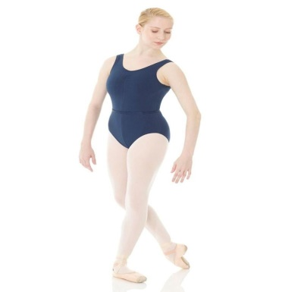
Mondor Adjustable Pinch Front Leotard 13520 (52 Black, 90 Ink Blue)
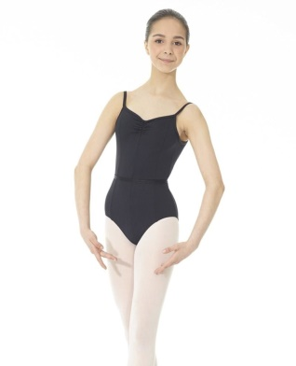

Mondor Empire Waist Leotard 3523 (52 Black, 90 Ink Blue)

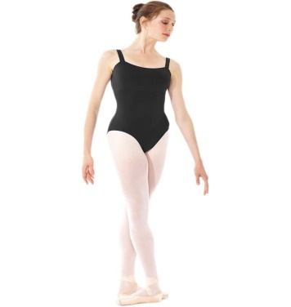

NOTE: Black bodysuits in any style are for Tap and Jazz exams
Navy bodysuits are for Graded RAD Ballet Exams (Grade 1-5)
Ink Blue bodysuits are for Vocational RAD Ballet Exams (Intermediate Foundation & higher)

MALE IDENTIFYING EXAM T-SHIRT, LEGGINGS/PANTS, SHORTS, AND TIGHTS OPTIONS

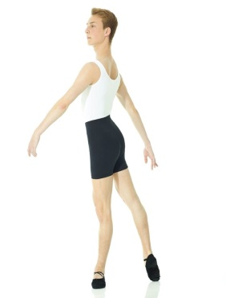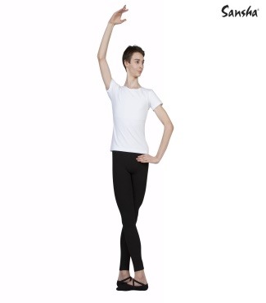These options are for Ballet exams.

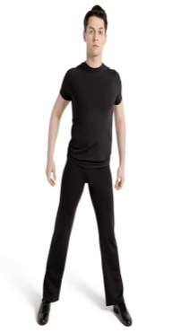This is used for Tap and Jazz Exams

BALLET

ALL LEVELS OF BALLET/BALLET TECHNIQUE/RECREATIONAL/ADULT: Hair in a secure ballet pancake bun made with hair pins and a hair net. Messy buns held with only an elastic or scrunchie are not acceptable. Short hair securely pinned back and off of the face. Students are responsible for their own supplies.
Female Identifying:
Navy or Ink Blue bodysuit.
Sheer Skirts are optional
All levels will wear Mondor Salmon tights.

Male Identifying:

White t-shirt, black jazz pant, leggings or shorts, white socks

Non-Binary:
Bodysuit & tights, dance shorts and tight fitting t-shirt & tights/socks

LEVEL 1, 2, 3 BALLET/BALLET TECHNIQUE 1 & 2/RECREATIONAL/TEEN BALLET: Leather Full Sole

Female Identifying: Pink

Leather Ballet Slipper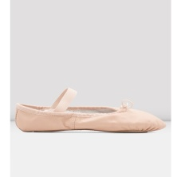

LEVEL 2 & 3 WILL REQUIRE CHARACTER SHOES – LOW HEEL

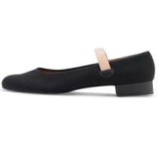

Male Identifying: Black

Leather Ballet Slipper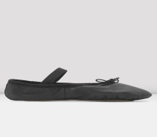

2 & 3 WILL REQUIRE CHARACTER SHOES

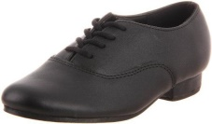

Non-Binary:

Full Sole Leather Ballet Slipper in your choice of colour. Character shoe in your choice of style. The colour of shoe chosen will indicate if the dancer prefers a male or female identifying costume.

LEVEL 4, 5 & 6 BALLET/BALLET TECHNIQUE 3 & 4/ADULT BALLET: Canvas Split Sole

Female Identifying: Pink

Canvas ballet slipper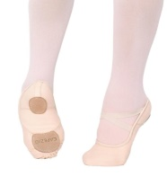

Level 4, 5 & 6 WILL REQUIRE CHARACTER SHOES – CUBAN HEEL

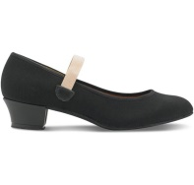

Male Identifying: Black

Canvas ballet slipper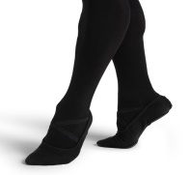

LEVEL 5 & 6 WILL REQUIRE CHARACTER SHOES

Non-Binary:

Split Sole Canvas Ballet Slipper in your choice of colour. Character Shoe in your choice of style. The colour of shoe chosen will indicate if the dancer prefers a male or female identifying costume.

DEMI-POINTE:

Female Identifying: Pink

Leather or canvas ballet slipper

Convertible Tights to access bare feet

Male Identifying: Black

Leather or canvas ballet slipper

Removable socks or convertible tights to access bare feet

Non-Binary:

Leather or Canvas Ballet Slipper in your choice of colour

POINTE SHOES: A well fitted pointe shoe, suitable to each individual – it is recommended that students have their teachers present to fit their first pair at Dance Street. Students will not purchase pointe shoes until the class teacher tells them they are ready to do so.

POINTE: With ribbons (and elastics if needed)

A well fitted pointe shoe, suitable to each individual. If dancers need to purchase a new pair in a new style, it is advised to coordinate having their teacher present to assist in the new fitting at Dance Street.

JAZZ/ENRICHMENT
NOVICE FOUNDATIONS

ALL LEVELS OF JAZZ/SYLLABUS CLASS/ADULT/NOVICE FOUNDATIONS/ENRICHMENT: Hair in a ponytail or bun, short hair securely pinned back and off of the face. Braided hair is not recommended when doing any type of turning.

Female Identifying:

Any style bodysuit and Mondor light tan tights. Black bodysuit is required if taking the official syllabus exam.

Jazz shorts are optional

NOTE: Enrichment will need access to bare feet.

Male Identifying:

T-shirt, jazz pants, leggings or shorts, socks. Black shirt and bottoms are required if taking the official syllabus exam

Non-Binary:
Bodysuit & tights or dance shorts and t-shirt & tights/socks

ALL LEVELS OF JAZZ/SYLLABUS CLASS/RECREATIONAL JAZZ/ADULT JAZZ: Leather Jazz Oxford with split sole. No laces. NOTE: Some levels may be asked to purchase both beige and black.

Female Identifying: Beige

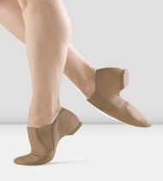

Male Identifying: Black

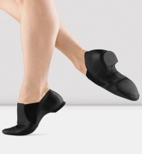

Non-Binary:

Leather Jazz Oxford with split sole in your choice of colour. The colour of shoe chosen will indicate if the dancer prefers a male or female identifying costume.

ENRICHMENT: Jazz Oxfords, and Bare feet. (Convertible tights)

Female Identifying: Beige

Male Identifying: Black

Non-Binary: Jazz Oxford with split sole in your choice of colour

NOVICE FOUNDATIONS: Leather Jazz Oxford with split sole. No laces

Female Identifying: Beige

Male Identifying: Black

Non-Binary:

Jazz Oxford with split sole in your choice of colour. The colour of shoe chosen will indicate if the dancer prefers a male or female identifying costume.

TAP
ALL LEVELS OF TAP/SYLLABUS CLASS/RECREATIONAL TAP/ADULT: Hair in a ponytail or bun, short hair securely pinned back and off of the face. Braided hair is not recommended when performing any type of turning.
Female Identifying:

Any style bodysuit and Mondor light tan tights.

Jazz shorts or sheer skirts are optional

Male Identifying:

T-shirt, black jazz pants, leggings or shorts, black socks

Non-Binary:
Bodysuit & tights or dance shorts and t-shirt & tights/socks

LEVELS 1 & 2 TAP/SYLLABUS CLASS: NO Slip-on Oxfords or Split Sole Tap

Female Identifying: BEIGE

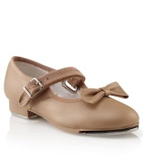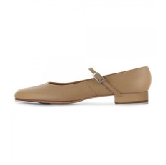

Male Identifying: BLACK

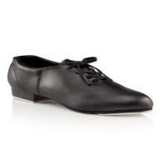

Non-Binary:

Full Sole Tap shoe with buckle or oxford with laces in your choice of colour. The colour of shoe chosen will indicate if the dancer prefers a male or female identifying costume.

LEVEL 3 TAP/SYLLABUS CLASS/RECREATIONAL TAP: NO Slip on Oxfords or Split Sole Tap

Female Identifying: BEIGE

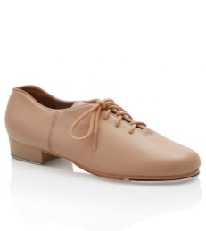

Male Identifying: BLACK

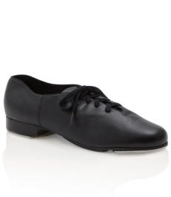

Non-Binary:

Full Sole Tap Oxford with Laces in your choice of colour. The colour of shoe chosen will indicate if the dancer prefers a male or female identifying costume.

ADULT TAP:

Female & Male Identifying &Non-Binary: Any style black tap shoe

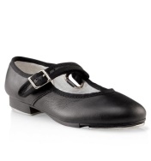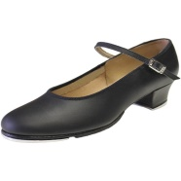

ACRO
RECREATIONAL AND COMPETITIVE: Hair in a ponytail or braid, short hair securely pinned back and off of the face. Long hair in a ponytail may get in the way when trying tumbling that requires being on the hands, so a bun or braid is recommended. Need access to bare feet.
Female Identifying:

Any style bodysuit and Mondor light tan tights. (recommended convertible or capri. Mondor light tan capri tights will be needed for recitals and competitions)

Jazz shorts are optional

No crop tops

NOTE: will need access to bare feet.

Male Identifying:

T-shirt, jazz pants, leggings or shorts, socks

Non-Binary:
Bodysuit & tights or dance shorts and t-shirt & tights/socks

ACRO: RECREATIONAL/COMPETITIVE: 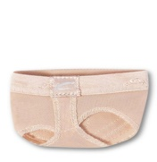

Female Identifying:

Bare feet

Capezio Foot Undee- H07 – needed for performances

Male Identifying:

Bare feet

Capezio Foot Undee- H07 – needed for performances

Non-Binary:

Bare feet

Capezio Foot Undee- H07 – needed for performances
HIP HOP
HIP HOP/HE DANCES TOO: Hair in a ponytail, short hair securely pinned back and off of the face
Male & Female Identifying & Non-Binary:
Comfortable loose fitting clothing such as leggings, sweat pants, t-shirts etc. – no jeans or crop tops.

HIP HOP/HE DANCES TOO – ALL LEVELS: Fully black, Clean Indoor High Top Runners (never worn outside)

Male & Female Identifying & Non-Binary:

Black High Top Runners – no white accents – all black

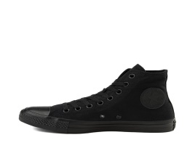

CONTEMPORARY/LYRICAL

CONTEMPORARY/LYRICAL: Hair in a ponytail, short hair securely pinned back and off of the face. Braided hair is not recommended when doing any turning.
Female Identifying:

Any style bodysuit and Mondor light tan tights.

Jazz shorts or sheer skirts are optional

NOTE: will need access to bare feet.

Male Identifying:

T-shirt, jazz pants, leggings or shorts, socks

Non-Binary:
Bodysuit & tights, dance shorts and t-shirt & tights/socks.

CONTEMPORARY – All LEVELS:

Female & Male identifying & Non-Binary: recommend wearing capri or convertible light tan tights. Mondor capri tights will be needed for the recitals and competitions.

Bloch Spin II- SO639

Capezio Hanami Pirouette- H064W

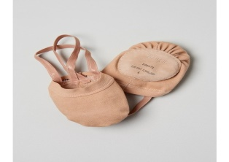

LYRICAL – ALL LEVELS: Leather Jazz Oxford with split sole. No laces.

Female Identifying: Beige

Male Identifying: Black

Non-Binary:

Jazz Oxford with split sole in your choice of colour. The colour of shoe chosen will indicate if the dancer prefers a male or female identifying costume.

SPARK PRESCHOOL/CREATIVE TOTS & KIDS
SPARK PRESCHOOL:
Male & Female Identifying & Non-Binary:
Comfortable loose fitting clothing

SPARK PRESCHOOL:

Male & Female identifying & Non-Binary: Jazz and tap shoes required. Beige or black in tap and jazz shoes are acceptable.

Tap: (must have Velcro closure)

Jazz: (no laces)
CREATIVE TOTS & KIDS: Hair in a ponytail, short hair securely pinned back and off of the face
Female Identifying:

Any style bodysuit and light tan tights.

Jazz shorts or sheer skirts are optional

Male Identifying:

T-shirt, jazz pants, leggings or shorts, socks

Non-Binary:
Bodysuit & tights, dance shorts and t-shirt & tights/socks

CREATIVE TOTS & KIDS – FOUNDATIONS: Ballet & Jazz

Female Identifying: Ballet

Male Identifying: Ballet

Non-Binary:

Full Sole Leather Ballet Slipper in your choice of colour.

CREATIVE TOTS & KIDS - RHYTHMS: Jazz & Tap

Female Identifying: Black or Beige Jazz

Female Identifying: Black or Beige Tap

Male Identifying: Black Jazz

Male Identifying: Black Tap

Non-Binary:

Jazz Oxford with split sole in your choice of colour

Full sole Tap shoe with buckle or tap oxford with laces in your choice of colour

DRAMA & VOCAL
(Tickle Trunk Creations, ACT-ivate, Genre Jumpers, Scene Stealers, Improv Club,
Voices & Vibes).
Male & Female Identifying & Non-Binary:
Comfortable loose fitting clothing such as leggings, sweat pants, t-shirts etc. – no jeans or crop tops. Hair up in a ponytail and pinned off of face.

Both Female and Male Identifying/Non-Binary:

Clean indoor shoes (never worn outside)

DRAMA & VOCAL VARIATIONS:

Female & Male Identifying & Non-Binary:

Clean Indoor Shoes (never worn outside OR jazz oxfords)

)

MUSICAL THEATRE
ALL MUSICAL THEATRE INCLUDING MINIS AND EXPRESSIONS (PERFORMANCE GROUP): Hair in a ponytail or bun, short hair securely pinned back and off of the face. Braided hair is not recommended when doing turning.
Female Identifying:

Any style bodysuit and Mondor light tan tights. No jeans or crop tops.

Jazz shorts or sheer skirts are optional

Male Identifying:

T-shirt, jazz pants, leggings or shorts, socks

Non-Binary:
Bodysuit & tights or dance shorts and t-shirt & tights/socks. No jeans or crop tops.

ALL MUSICAL THEATRE PROGRAMMING INCLUDING MINI AND EXPRESSIONS: Jazz oxford with split sole. No Laces

Female Identifying: Beige

Male Identifying: Black

Non-Binary:

Jazz Oxford with split sole in your choice of colour. The colour of shoe chosen will indicate if the dancer prefers a male or female identifying costume.

BROADWAY BOUND/ BROADWAY NOW/ UNDER THE SEA/ MICKEYS DANCE PARTY: Hair in a ponytail, short hair securely pinned back and off of the face. Braided hair is not recommended when doing turning.
Female Identifying:

Any style bodysuit and light tan tights.

Jazz shorts or sheer skirts are optional

Male Identifying:

T-shirt, jazz pants, leggings or shorts, socks

Non-Binary:
Bodysuit & tights, dance shorts and t-shirt & tights/socks

Female Identifying: Beige

Male Identifying: Black

Non-Binary:

Jazz Oxford with split sole in your choice of colour. The colour of shoe chosen will indicate if the dancer prefers a male or female identifying costume.

Triple Threat Junior Production - ALICE IN WONDERLAND JR:
Male & Female Identifying & Non-Binary:
Comfortable loose fitting clothing such as leggings, sweat pants, t-shirts etc. – no jeans or crop tops. Hair up in a ponytail and pinned off of face.

Female Identifying: Beige

Male Identifying: Black

Non-Binary:

Jazz Oxford with split sole in your choice of colour.
Triple Threat Teen Production -SOMETHING ROTTEN JR:
Male & Female Identifying & Non-Binary:
Comfortable loose fitting clothing such as leggings, sweat pants, t-shirts etc. – no jeans or crop tops. Hair up in a ponytail and pinned off of face.

Female Identifying: Beige

Male Identifying: Black

Non-Binary:

Jazz Oxford with split sole in your choice of colour

ADULT CABARET: Hair in a ponytail, short hair securely pinned back and off of the face. Braided hair is not recommended when doing turning.

Male & Female Identifying & Non-Binary:
Any type of comfortable clothing such as bodysuit and tights, jazz shorts, leggings, t-shirts etc. – no jeans or crop tops.

Female Identifying: Beige or Black

Male Identifying: Black

Non-Binary:

Jazz Oxford with split sole in your choice of colour.

